Task c&d:

|  |  |  |  |
| --- | --- | --- | --- |
|  | PMF | User CF | Movie CF |
| Avg RMSE | 0.8962 | 0.9668 | 0.9683 |
| Avg MAE | 0.6897 | 0.7433 | 0.7446 |

Task E

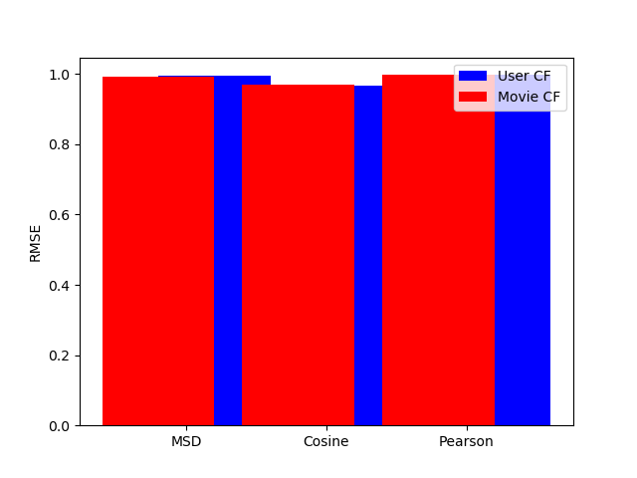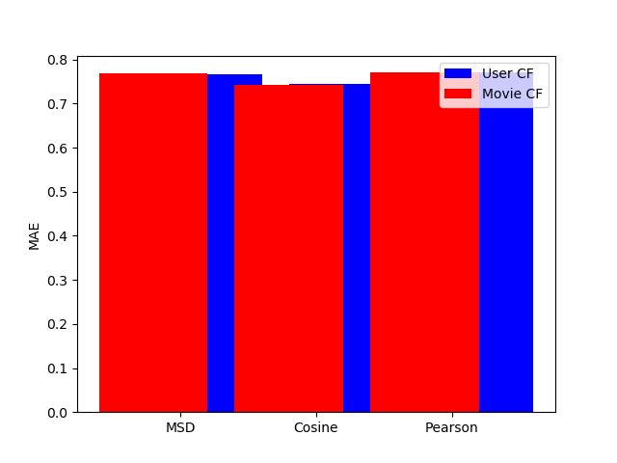:

Task F and G:

The best K for both is around 90. For RMSE the best is about equivalent in terms of value. However, the MAE does perform slightly better with the best K for Movie CF.

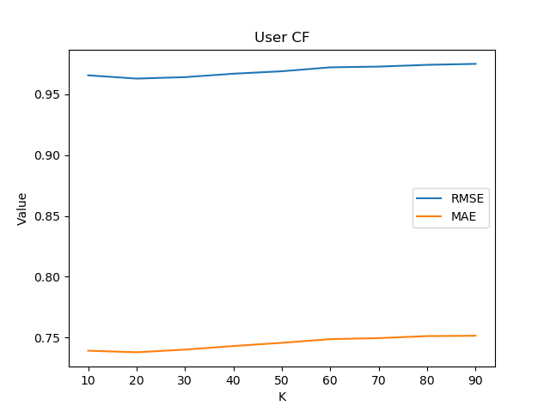

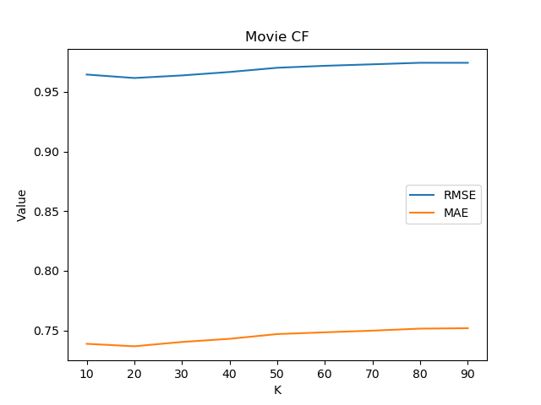

Additional Questions:

Approximately how many hours did you spend on this assignment?

5 hours

Which aspects of this assignment did you find most challenging? Where there any significant stumbling blocks?

Reading through the “Surprise” documentation was a nightmare nothing was where I thought it would be (especially for CF). Stumbling blocks: the ratings.csv is too large for my computer and google colab to create the recommender systems. I had to use the ratings_small.csv get it to run on a computer I have access to.

Which aspects of this assignment did you like? Is there anything you would have changed?

Nothing I liked/disliked. Was a good assignment overall.

Github: